Software Project CA1

Game Design Document

Jake Black (N0019332



Contents

Basic Information: 2

Story and Gameplay 2

Overview: 2

Intended Game Systems: 2

Game flow: 3

Characters and controls: 3

Main gameplay concepts and platform-specific features: 4

Game world: 5

Interface: 6

Mechanics and power-ups: 7

Gameplay mechanics: 7

Power-ups: 8

Enemies and bosses: 9

Main enemy: 9

Boss: 9

Cutscenes, bonus material, and comps: 10

# Basic Information:

**Title:** ‘College Escape’

**Target platform:** Web browser, mobile.

**Target audience:** Aims to appeal to enthusiasts of the survival-horror genre. Suitable for ages seven and up.

**Target rating:** PEGI 7 (ESRB Everyone 10+), due to the presence of sounds or visuals which may be frightening to younger children and the presence of unrealistic, non-detailed violence.

# Story and Gameplay

## Overview:

*College Escape* is a survival-horror platformer in which the player must escape from a dilapidated college building. The player will soon find the building far from deserted, as they attempt to avoid the monster lurking the halls. With this game I will aim to invoke the sense of foreboding and ominous atmosphere of survival-horror games in a retro-style platformer. I will aim to avoid needless complexity, instead opting for genuinely enjoyable core game mechanics which keep the player coming back.

## Intended Game Systems:

The game’s action will take place entirely within the college building, albeit on multiple floors. Players will aim to move down through the floors which act as the levels or arenas. Level backgrounds will appear practically identical, the differences being in the increasing ferocity of the enemy’s attacks and the fervour with which the player is pursued, along with new randomised areas in which the player can hide.

The player will use the cursor keys to move through the hallways, attempting to reach the stairwell which will lead them down to the next floor. To unlock the door, the player will also need to collect a ‘keycode’ from somewhere in the hallway. The game will culminate in a boss battle with a ‘door guardian’ type enemy on the ground floor, who holds the last keycode used to unlock the front door.

As is commonly seen in the survival-horror genre, the player will be far more vulnerable to their enemies than vice-versa. While attacks are possible, they deal little damage and should be utilised in a ‘hit and run’ method. The player’s best defence against their enemies is hiding. Doorways will be scattered randomly along every hallway, inside which the player may hide using the shift key when within range of the doorway.

# Game flow:

As is typical of the survival-horror genre (seen in games like ‘Outlast’, 2013) the players skillset or the effectiveness of their attacks will not increase along with the difficulty of the game. The player’s defensive capabilities will remain just as effective as the levels become harder, encouraging a defensive gameplay style to overcome otherwise insurmountable difficulty. However, some special collectible may be required for the final level when the player must face the boss-type enemy. This level should be difficult, but obviously not *impossible*.

The number of enemies should not increase as the player descends through the levels, but rather a single enemy should attack more frequently and deal increasing levels of damage should the player fail to avoid it in time. The exception to this should be the boss-type enemy on the final level.

# Characters and controls:

The player will control a single character, having been presented with a choice of three at the start menu. These characters which each have unique abilities and allow the player to personalise their playstyle somewhat. All the characters can hide in doorways, where they are completely protected from the enemy, provided they hide quickly enough.

This should remain the most effective means of progressing through the levels. No attack should be hugely effective on the enemy, preventing the player from rushing through a level regardless of their character choice.

These will include:

1. **Mage:** Can use long-range attacks on enemies, dealing 2.5 hit points. Melee attacks deal 0.5 hit points.
2. **Cleric:** May temporarily stun enemies with a smoke cloud which deals no damage. Melee attacks count for 1 hit point.



‘Cleric’ performing his smoke attack.

1. **Fighter:** May special attack for 5 hit points of damage, or melee attack for 2 hit points of damage.



# Main gameplay concepts and platform-specific features:

The game will feature platformer-style movement in the sense of purely two-dimensional movement, but without the typical jumping and climbing seen in most platform games. The player should be limited to moving left and right, hiding, or attacking the enemy. As the game is set in a college building, the game is divided into levels in the form of the building’s storeys, with a total of 4 distinct levels.

Hardware limitations should not be a problem for anyone seeking to run the game, and the simple controls should allow the game to translate well to touch controls.



Mobile controls concept (placeholder character)

Game world: 

Concept of Cleric running through game world with parallax background.

The game environment will be gloomy, imparting upon the player the sense that something has gone very wrong not only within the college building, but also in the imagined, wider game world.

Dim lighting will appear above doorways or randomly scattered along the ceiling. Lights will occasionally flicker, or cut out completely for extended periods of time, leaving the player in almost complete darkness.

The levels should be connected via stairwells which are reached through doors located at the end of each level. A short cutscene animation should show a cross section of the building with the player descending the stairs to the next level.

The player will be unaware of how they came to be in this college, but a cutscene animation at the beginning of the first level will make clear their goal of escaping the college by panning down through the levels and highlighting the front door.

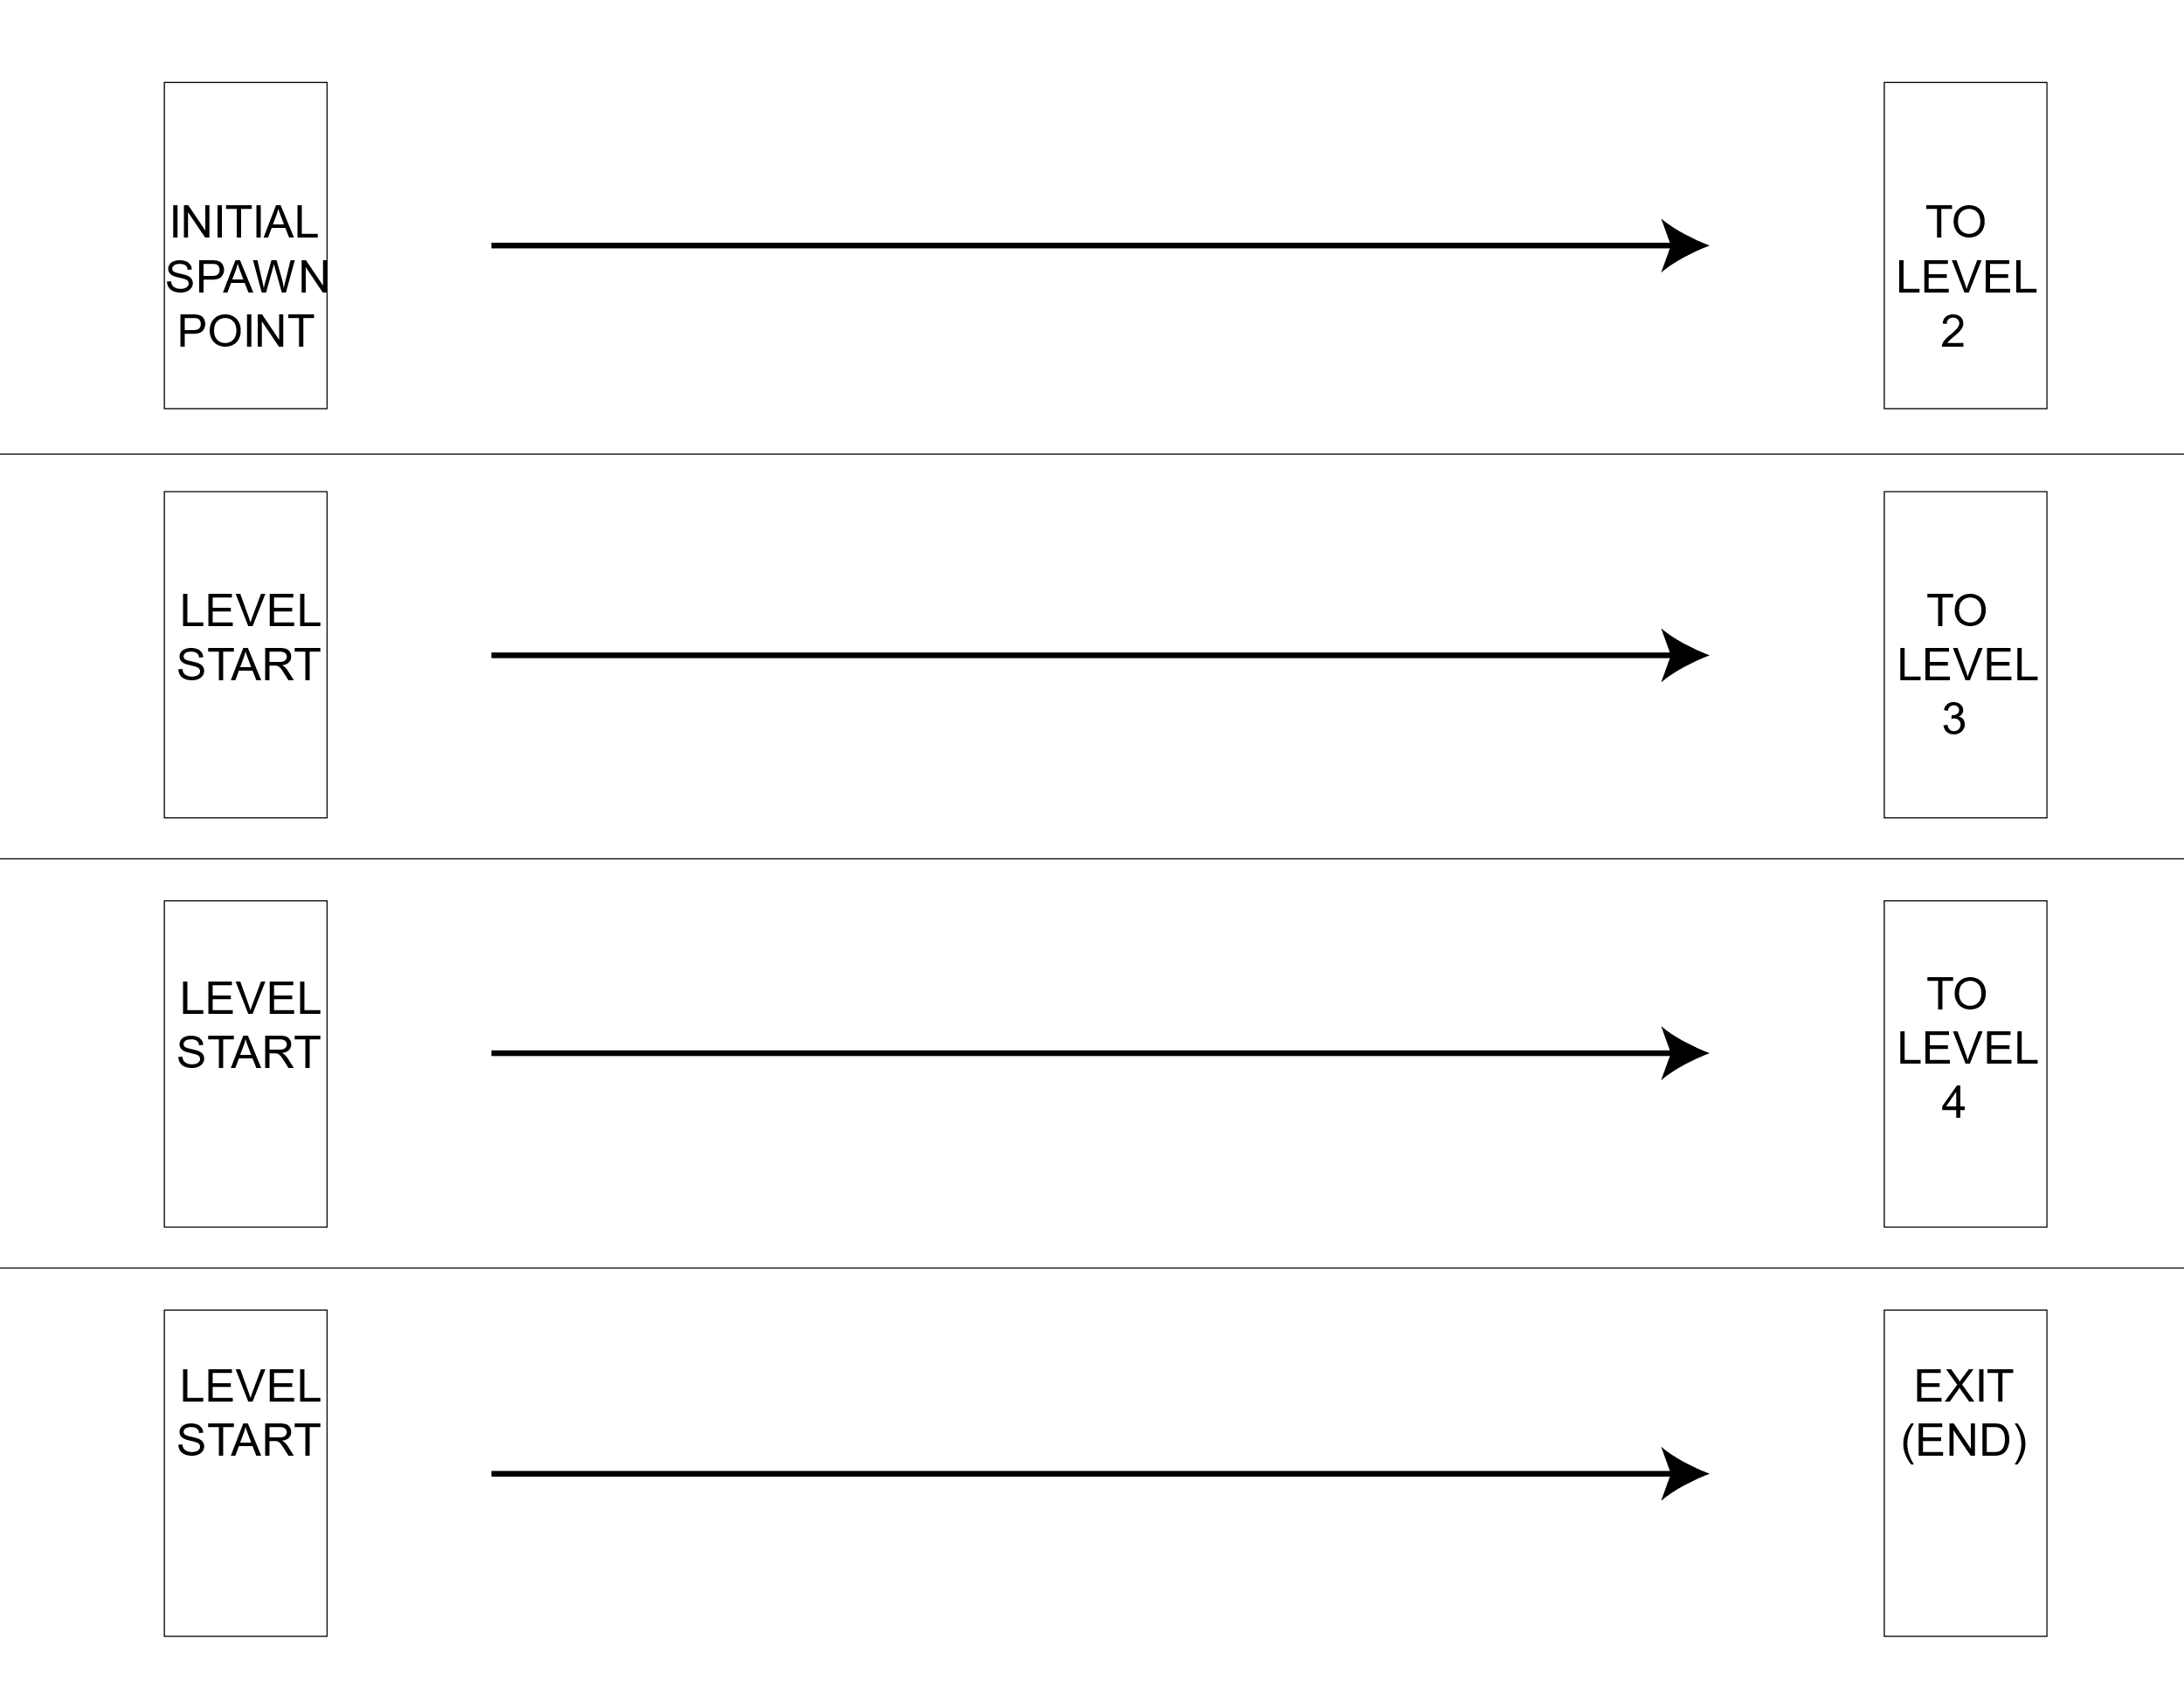

# Interface:

A short opening sequence features the game’s font fading in from black and slowly increasing in size from the centre. A menu screen will appear with the options ‘Start game, options, controls’. Options should provide access to sound configuration options and/or video options.

Upon starting a new game, the player should be presented with a character selection screen. Ominous music should play on this screen.

Three characters will be available to choose from, each with their own unique strengths and weaknesses.

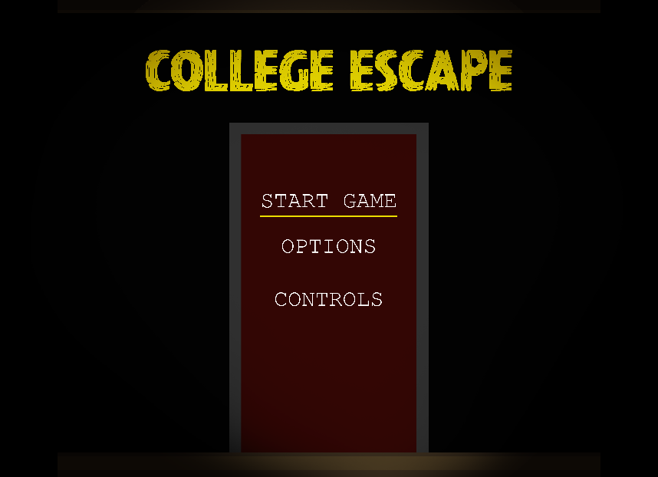

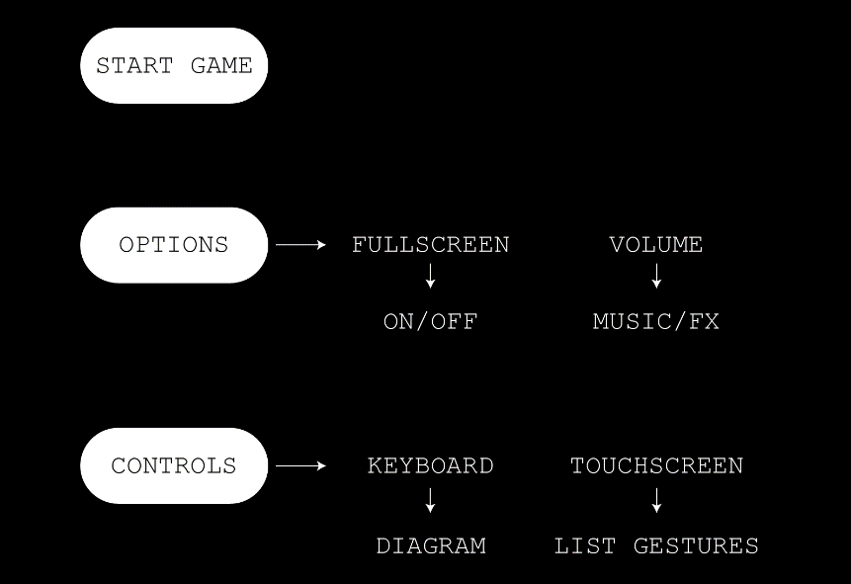

# Mechanics and power-ups:

## Gameplay mechanics:

One gameplay mechanic which is somewhat unique among platform games is the ability to hide by backing into a doorway. It may also be possible to hide to a lesser degree by backing against a wall, cloaking the player partially in darkness. The ability to hide is a key mechanic in the game in that the enemy’s attacks are far more damaging to the player than vice-versa, so the hiding ability must be utilised to complete the game. Player health will only regenerate while hiding for 0.1HP per second.



‘Fighter’ Character using a door to hide.

## Power-ups:

One type of power-up that may be implemented is a torch/flashlight item which could allow the player to see further down the hallway for a short amount of time, allowing the player to avoid the enemy more easily. This power-up, if implemented, may or may not spawn in any given game session, and would be placed in a random location and level if so.



Concept of player holding torch power-up.

# Enemies and bosses:

## Main enemy:

The main enemy seen on the first 3 levels of the game is a type of zombie, possibly a teacher or student who did not escape the building in time following whatever catastrophe has occurred within the game world.

The main enemy will pursue the player in various conditions. It will search for the player constantly at a static speed, but if the player comes within a certain range of the enemy while not hidden, the enemy will move toward the player at 1.2x player speed. The enemy’s melee attack does 10 hit points of damage, and its long-range attack does 5 hit points of damage.

The enemy increases in size when attacked, increasing its attack strength by 1 hit point for long and short-range attacks up to a maximum of 12HP for melee and 7HP for long-range and a maximum size of 1.5x its original size. This enemy will also increase in speed slightly as the player descends through the levels, up to a maximum of 1.5x its original speed.

## Boss:

The final boss enemy is the ‘door guardian’. This enemy guards the exit to the street and endpoint of the game. Its attributes are the same as the original enemy’s in that it attacks using melee and long-range attacks for 10 and 5 hit points respectively, increasing in speed and attack strength with each attack up to a certain point.

This enemy appears only at the 4th and final level of the game. The player should be given plenty of opportunities to hide from the door guardian, giving the player’s health time to recover. Once defeated, the door guardian will drop the ‘keycode’ to unlock the door and exit the college, completing the game.

# Cutscenes, bonus material, and comps:

I have only three cutscene animations in mind for College Escape. The first should appear at the start of the game, panning through a cross-section of the college building to a highlighted front door, highlighting the door to the stairwell on each level as the camera pans. This is to show the player their objective and how to reach it.

A similar animation should be shown upon finishing a level, showing a cross-section of the stairwell as the player descends to the next floor. Finally, when the player collects the keycode on the final level, a cutscene animation should show the player moving to the door and typing the code into the keypad. The player then exits the building and the screen fades to black.

These animations should be created in the form of a Phaser animation.